AWS Serverless Workshops 2024 – code no longer available
https://webapp.serverlessworkshops.io/

Build a Serverless Web Application (Wild Rydes)

AWS Tutorial with Amplify

You will have to circumvent creating roles and have to use LabRole instead.

GitHub Source
is now archived under:
https://github.com/aws-samples/aws-serverless-webapp-workshop

Doing the project with an S3 Bucket, AWS Academy and ILIAS

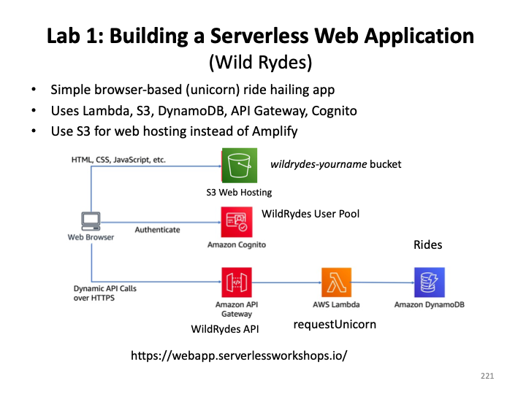

- Host a Static Website with S3
Create an S3 Bucket with name: wildrydes-firstname-lastname, use defaults (for now). Allow objects to become public.

Download content from ILIAS and upload it to your S3 bucket
Download the wildrydes-site.zip file from the WildRydes subfolder in the ILIAS Course Code folder and unzip it.
From the S3 console, navigate to the bucket, choose upload from the Overview.
Upload the content of the following directory (without selecting the directory itself).

Note: Amazon has removed access to the public folder for WildRydes.

Update the permissions to allow public access to all objects with a policy

Choose the permissions tab, enable changing policies, then upload the following policy
See also:
https://aws.amazon.com/premiumsupport/knowledge-center/read-access-objects-s3-bucket/
{
"Version": "2012-10-17",
"Statement": [
{
"Effect": "Allow",
"Principal": "*",
"Action": "s3:GetObject",
"Resource": "arn:aws:s3:::[YOUR_BUCKET_NAME]/*"
}
]
}
Enable static website hosting (under properties tab)

Point to index.html, remember public url., e.g.
http://wildrydes-kristof-krk.s3-website-us-east-1.amazonaws.com/
Explore the static website (look at the serverless manifesto under APPLY)

- User Management

Create a Cognito User Pool (to be renamed wildrydes)

In the the console, choose ‘Traditional Web Application’ (the default).
Name the application (WildRydesApp).
Select email for authentication.

Create the pool and look at the overview.
You will have been given a name by AWS, rename the pool to e.g. wildrydes.
Note the pool id, e.g. us-east-1_Q4qehpi7s
From the left-hand menu, select app clients and note the client id for WildRydesApp., e.g. 4m164lm0jhfsi7v80l76ep1dc

Update the configuration file in the bucket (config.js in js folder)
You can also just modify config.json from ILIAS and upload this.

Note: You have to download, modify and then re-upload the file if you want to test it out before all steps are completed. After each upload, check that config.js is readable for all.
Substitute your values for UserPoolID and UserPoolClientID as well as region.

Note: Within the github repository we are using, Amazon provides an application to handle registration etc. This can easily be reused in different settings (cognito-auth.js)
Test the implementation (doesn’t work as in prior years)
Go to /register.html at your bucket url, or select ‘GiddyUp’ button
Verify the registered email is indeed in the user pool

Instead, manually register a user (Users tab on left side).
Then go to app client and “Login Pages”.
Modify the “Allowed Call-back URL” to e.g. https://wildrydes-krk.s3-website-us-east-1.amazonaws.com/ride.html
Click “View Login Page” and login as the user. This gives you a token to use.

- Serverless Service Backend

We will use Lambda and DynamoDB to process requests for rides.

Create a DynamoDB table (from console)

Table Name: Rides Partition Key: RideId, Make sure you use exactly these names, they are case sensitive and need to match the keys in the function code.

Note the ARN, e.g. arn:aws:dynamodb:us-east-1:453545715725:table/Rides

Create a WildeRydesLambda IAM role (not needed for AWS Academy, use LabRole)

Use the IAM console to create a new role. Name it WildRydesLambda and select AWS Lambda for the role type. You'll need to attach policies that grant your function permissions to write to Amazon CloudWatch Logs and put items to your DynamoDB table.
Attach the managed policy called AWSLambdaBasicExecutionRole to this role to grant the necessary CloudWatch Logs permissions. Also, create a custom inline policy for your role that allows the ddb:PutItem action for the table you created in the previous section (on the summary page for the role)
Choose DynamoDB service, allow ‘PutItem’, add ARN for the table just created.
Choose ‘Review Policy’, Enter DynamoDBWritePolicy as the name, and create.

Create a Lambda Function
Use the AWS Lambda console to create a new Lambda function called requestUnicorn that will process the API requests (keep Create from Scratch selected).
The original version of the workshop worked with Node.js 10.x, which is no longer supported.
It requires aws-sdk V2, which is no longer bundled in the supported versions (18.x upwards)
Choose Node.js 18.x
Create a deployment package in a local project directory.
Use the provided requestUnicorn.js example implementation for your function code. Copy it to index.js in your project directory.
Then:
npm install aws-sdk
zip -r function.zip index.js node_modules package.json
package.json needs to contain
"dependencies": {
"aws-sdk": "^2.1234.0" // Version may vary
}
Alternatively, function.zip is provided in the ILIAS WildRydes folder.
You may have to refresh the browser to see the changes.
Make sure you deploy after changing the code.
Make sure to configure your function to use the WildRydesLambda IAM role you created in the previous section. (For AWS Academy, use LabRole)

Verify the Installation
Configure test event with code provided on the website, call the event ‘TestRequestEvent’
{
"path": "/ride",
"httpMethod": "POST",
"headers": {
"Accept": "*/*",
"Authorization": "eyJraWQiOiJLTzRVMWZs",
"content-type": "application/json; charset=UTF-8"
},
"queryStringParameters": null,
"pathParameters": null,
"requestContext": {
"authorizer": {
"claims": {
"cognito:username": "the_username"
}
}
},
"body": "{\"PickupLocation\":{\"Latitude\":47.6174755835663,\"Longitude\":-122.28837066650185}}"
}

- Create a RESTful API

The static website you deployed in the first module already has a page configured to interact with the API you'll build in this module. The page at /ride.html has a simple map-based interface for requesting a unicorn ride. After authenticating using the /signin.html page, your users will be able to select their pickup location by clicking a point on the map and then requesting a ride by choosing the "Request Unicorn" button in the upper right corner.
Note: Change the version of the map software js.arcgis.com to 4.6 in ride.html
If you're interested in how the browser code works that calls this API, you can inspect the ride.js file of the website. In this case the application uses jQuery's ajax() method to make the remote request.
Create an API (called WildRydes)

Select ‘edge optimized’ for use through the Internet.

Create a Cognito Pool Authorizer

Amazon API Gateway can use the JWT tokens returned by Cognito User Pools to authenticate API calls. In this step you'll configure an authorizer for your API to use the user pool you created in Module 2.

Create a new Authorizer “WIldRydes’ of type Cognito, entering Authorization as Token Source.

Go to static website /ride.html, then log in, use the token to test the authorizer.

Create a New Resource and Method for the API Gateway

- In the left nav, click on Resources under your WildRydes API.
- Create Resource.
- Enter ride as the Resource Name.
- Ensure the Resource Path is set to ride.
- Select Enable API Gateway CORS for the resource. Cross-Origin Resource Sharing (CORS) is a mechanism that uses additional HTTP headers to tell browsers to give a web application running at one origin, access to selected resources from a different origin.

- Click Create Resource.
- With the newly created /ride resource selected, on the right hand side select Create Method.
- Select POST from the new dropdown that appears
- Select Lambda Function for the integration type.
- Check the box for Use Lambda Proxy integration.
- Select the Region you are using for Lambda Region.
- Enter the name of the function you created in the previous module, requestUnicorn, for Lambda Function.
- Choose Save. Please note, if you get an error that you function does not exist, check that the region you selected matches the one you used in the previous module.
- Add an Authorizer (left panel), choose Cognito, select wildrydes from dropdown. Token Source is Authorization, leave Token Vailidation empty.
- Edit the POST method request settings to add wildrydes as the authorization (pull down menu).

Deploy API (from Actions Drop-down List)
Choose ‘prod’ for ‘new stage’
Note the Invoke URL, e.g. https://pe2eabit43.execute-api.us-east-1.amazonaws.com/prod

Note: ArcGIS changed

if you are using js.arcgis.com in your ride.html - change the version from 4.3 to 4.6 and redeploy
<script src="https://js.arcgis.com/4.6/"></script>

Change config.js (with Invoke URL) and upload to your S3 bucket

Test the implementation by navigating to /ride from the URl of the website.

Serverless Data Processing (Wild Rydes)
https://data-processing.serverlessworkshops.io/
- Capture, process and analyze sensor data from the fleet of unicorns.
- Uses Kinesis, Lambda, DynamoDB, (Cognito) and S3.

Kinesis Stream: wildrydes
Cognito Identity Pool: wildrydes
e.g. us-east-1:3d64b555-45ee-4652-b6bf-cfabf1bd7fb5

NOTE: You cannot create the required roles for the identity pool, so the dashboard won’t work

Second Kinesis Stream: wildrydes-summary

SELECT * FROM "default"."wildrydes" limit 10; (instead of the command in the instructions)

Cognito and Lambda
https://aws.amazon.com/blogs/compute/securing-lambda-function-urls-using-amazon-cognito-amazon-cloudfront-and-aws-waf/

